Quarterly Report – Public Page

Date of Report: 2st Quarterly Report, March 26, 2025
Contract Number: 693JK32410001POTA
Prepared for: Government Agency: DOT and Co-funders
Project Title: Monitor Active Vapor Corrosion Inhibitors
Prepared by: Pipeline Research Council International (PRCI), Inc.
Contact Information: Janie Norton, jnorton@prci.org 703-205-1600 ext: 105
For quarterly period ending: March 31, 2025

1: Items Completed During this Quarterly Period:

Item # | Task # | Activity/Deliverable | Title | Federal Cost | Cost Share
1 | 5 | Kick-off meeting with all stakeholders | Meeting summary and action items to be included in the quarterly report | $3,149 | $3,149
10 | 5 | 2nd quarterly status report & project management | Submit 1st quarterly report | $5,474 | $5,474

The project work started towards the end of March 2025, various technical activities are being started.

2: Items Not Completed During this Quarterly Period:

Item # | Task # | Activity/Deliverable | Title | Federal Cost | Cost Share
2 | 1 | Literature review with focus on the VCI monitoring and replenishment | Summary of the literature review | $2,859 | $2,859
4 | 1 | Tank operator survey on effectiveness monitoring and replenishment plans | Summary to be included in the quarterly report | $4,560.50 | $4,560.50
5 | 2 | Develop test matrix for determining VCI effective concentration | Test matrix summary to be included in the quarterly report | $4,560.50 | $4,560.50
6 | 2 | Develop a sampling plan to measure VCI effective concentrations in the VCI treated tanks | Sampling plan summary to be included in the quarterly report | $4,886.25 | $4,886.25
7 | 3 | Develop a test matrix for determining minimum VCI non-effective concentrations | Test matrix summary to be included in the quarterly report | $4,560.50 | $4,560.50
8 | 3 | Start escape of the VCIs from the large-scale experiments | Summary of starting the VCI escape to be included in the quarterly report | $10,424.00 | $10,424.00
9 | 2 | Order materials and supplies to start laboratory work | Summary to be included in the quarterly report | $29,969.00 | $29,969.00

The project is behind schedule due to contracting delays between PRCI and BSRA.

3: Project Financial Tracking During this Quarterly Period:

Note that this chart reflects Federal share only:

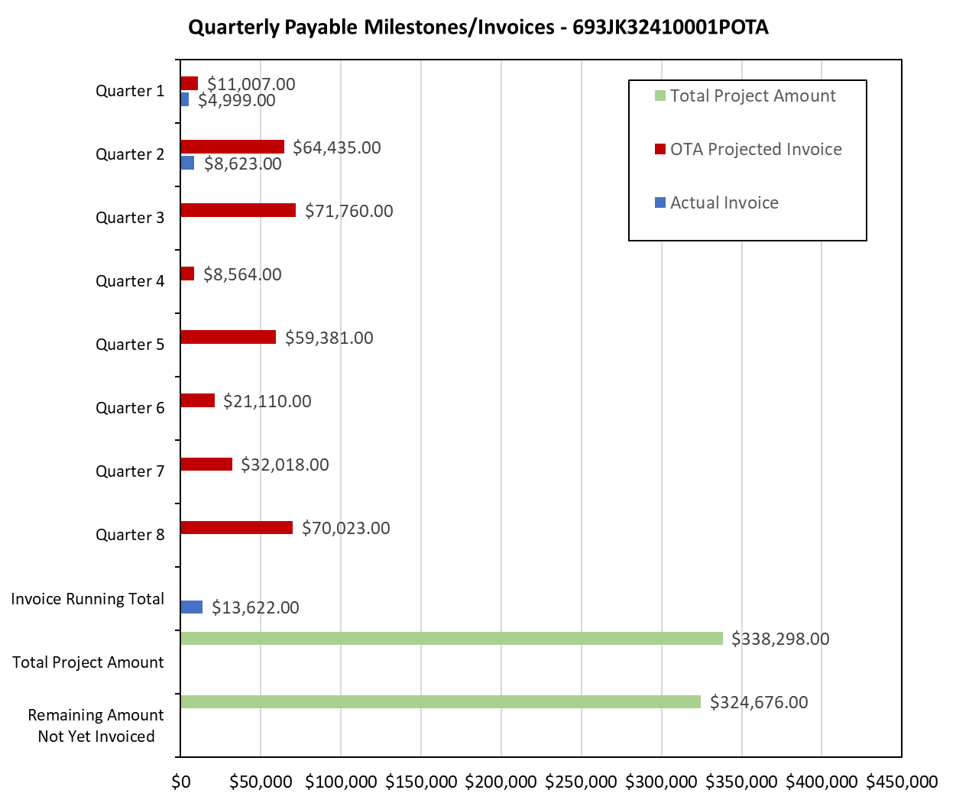

4: Project Technical Status –

Item 1, Task 5 ⎯ Kick-off meeting with all stakeholders, Meeting summary and action items to be included in the quarterly report: The kick-off meeting was held on 3/17/2024. The stakeholders included tank operators, VCI vendors, and PHMSA staff. No specific action items were identified in the meeting. This item links to items 1 in Attachment 1 Team Project Activities. This item links to item 1 in Attachment 2 Project Deliverables.

Item 10, Task 5 ⎯ 2nd quarterly status report & project management, Submit 2nd quarterly report: The second quarter meeting was held on March 19,2025. This report satisfies this item. This item links to item 14 in Attachment 1 Team Project Activities. This item links to item 19 in Attachment 2 Project Deliverables.

5: Project Schedule –

The project is behind schedule. The project team will try to catchup as much as possible during the next quarter.

